Lesson 2
Installing the MPLAB IDE

Overview
Introduction |  | This lesson walks through the download and installation of Microchip’s MPLAB Integrated Development Environment.
In this section |  | Following is a list of topics in this section:
 | Description |  | See Page
 | Downloading the IDE |  | 2
 | Unpacking the ZIP File |  | 4
 | Installing MPLAB |  | 6
 | Documentation |  | 7
 | Wrap Up |  | 8

Downloading the IDE
Introduction | Before we can do anything with the PIC, we need to obtain the development software. This software is available free from Microchip.  The Integrated Development Environment, or IDE, is a pretty substantial download, 26 Megabytes. Depending on your Internet connection, you may want to set aside substantial time to do this download.
Microchip’s Website | The Microchip website is a wealth of information for developers, so rather than simply handing you an URL for downloading, we are going to connect to the root of the website first.  Point your browser to  http://www.microchip.com  You will be presented with a selection of a text version or a graphics version. Since the text version will be faster, we will select that. If you allow cookies, this screen won’t be shown on successive visits.
Navigating to development tools | The left side of the page shows an outline of Microchip’s site. We want to go to the development tools so select (obviously), Development Tools:  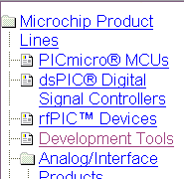  Now, select New MPLAB:  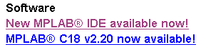  And finally, ‘Download the latest version!’:  
 | Continued on next page
Downloading the IDE, Continued
Selecting the Version | You need to choose how you want to do the download. If you are connected to the Internet over a high speed line (cable modem or similar), you probably want to choose ‘MPLAB® IDE v6.30’. If you have a slow connection (dial-up), it will probably work better for you if you download the individual floppy images.  There is nothing inherently wrong with downloading the full, 26.64 Mb image over a dial-up. The problem is that dial-ups often have reliability issues, and the full download is going to take several hours. If your connection is sufficiently reliable, then the full download may still be the right choice.  Click on the ‘D/L’ link to the right of your selection.
Starting the Download | You have two choices for downloading. The difference is in the protocol used to actually do the transfer. The FTP choice is a little ‘lighter weight’ and so more QRP-like. However, many times your browser may not be set up to pass the proper information to an FTP server, so you must use the HTTP option. The performance difference really isn’t very great.  Click on the download link:  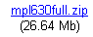  In the ‘File Download’ dialog, click on the ‘Save’ button.  You will be presented with a ‘Save As’ dialog. Navigate to the folder you wish to save the file in, and click the ‘Save’ button.  The download will take a while even on a fast circuit. On a cable modem, a ‘while’ is a couple of minutes. On a dial-up, several hours.  When the download is complete, click on ‘Close’.  If you have chosen to download the individual floppy images, repeat this process for each floppy.

Unpacking the ZIP File
Introduction | The downloaded file is in the form of a ZIP file. This is a compressed format that makes the download shorter but cannot be used directly. To use the file, we need to ‘unzip’ it.
Unzipping Programs | There are 3 different approaches you may use to unzip the file.  If you are using a newer version of Windows which understands zip files, go to the Windows XP block.  If you are using WinZip, which is a commercial program, go to the WinZip block.  If you are using Info-Zip, which is an open-source program, go to the Info-Zip block.
Info-Zip | Info-Zip (http://www.info-zip.org/pub/infozip/) is an open source zip program available on a wide range of platforms. It can be used not only on Windows, but also on DOS, Linux, and dozens of other platforms. If you are just downloading Info-Zip now, the file you need is unz550xN.exe. Run the program from the command line to create the various programs that comprise the unzip utility.  Create a working directory. If unzip is not on your path, you will need to know where it is. Navigate to the working directory and type:  Unzip [zip directory]mpl630full  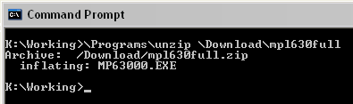  To create Mp63000.exe in the working directory.  Go to the Installing MPLAB map.
 | Continued on next page
Unpacking the ZIP File, Continued
WinZip | WinZip is a commercial program which can be downloaded from http://www.infozip.com. When WinZip is installed on your system, double-clicking a zip file will start WinZip.  Create a temporary folder which will be used to store the installation files. Then, double-click mpl630full.zip, you should see a window like:  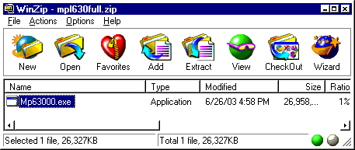  Drag Mp63000.exe from the WinZip window to the temporary folder you just created.  Go to the Installing MPLAB map.
Windows XP | Windows XP understands zip files natively. Create a working folder to hold the installation files. Double-click mpl630full.zip. This will open a new window containing Mp63000.exe. Simply drag the file from the zip folder into your working folder.  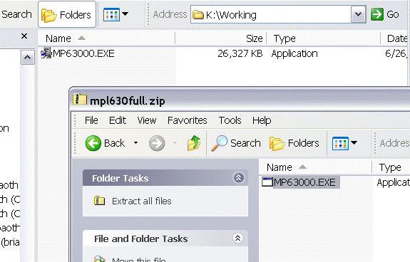

Installing MPLAB
Introduction | Now that we have the software downloaded, we can install it.  Before installing the IDE, close all other windows, except for a single Explorer window showing the working folder we created in the above step.
Starting Installation | If you are using Windows NT, Windows 2000, or Windows XP, you should log on to an account with administrative privileges to install the IDE.  Double-click on the MP63000.EXE icon. After a few seconds, you will see the Welcome panel of the installation wizard. Click the Next button.  Read and agree with the MPLAB license.
Choosing a Folder | The default folder for installation is C:\Program Files\MPLAB IDE.  A folder with spaces in the name can be a problem for using the IDE with older programs, as hams often do. Also, a long path name can be an issue.  If you choose a folder other than the default, a path without spaces will generally be preferable to a path with spaces, and a shorter path is generally preferable to a long one. In any case, you should keep the path length shorter than 219 characters.  Once you have selected a folder, click Next.
Choices, choices | If you haven’t previously installed MPLAB, there is no need to make backup files.  On the other hand, it probably is a good idea to have shortcuts added to the start menu.  Personally, I like to have the shortcut to the IDE on my desktop. You may think it adds too much clutter.  On ‘Ready to Install!’, click Next yet again.
Finishing up the Installation | There’s nothing very exciting in the README files, but if you would like, go ahead and read them. Be advised, there’s a bunch of them,  At this time, it’s not necessary to install the USB driver. Click Next, Next, Continue, Finish.  Close the browser windows opened by the installation.
Cleaning Up | The working folder you created and its contents are no longer needed. You may delete them at this time.  The zip file you downloaded is also no longer needed. You may wish to copy this file (or files) to a CD in case you want to reinstall the IDE or install it on another computer.

Documentation
Introduction | Now that we have the IDE installed and ready to go, there are a couple of pieces of documentation we would like to have from Microchip’s site.
The 16F84A Datasheet | This datasheet (more like a book, actually) contains all the information you could possibly want about the PIC 16F84A chip.  From the top of Microchip’s website, select ‘PICmicro® MCUs’:  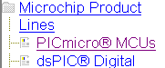  next, select ‘Datasheets’    And then select the PIC16F84A from the microcontrollers dropdown:  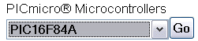  And click the ‘Go’ button. Then, click ‘D/L’ next to 35007b.  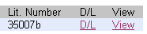  Save the file in a place you wish to keep documentation.
Reference Card | Microchip has a nice reference card that is handy for using the MPLAB. Go back to the ‘Datasheets’ page above, but this time, use the ‘Development Tools’ dropdown:  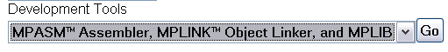  This time, select the Quick Reference Card:  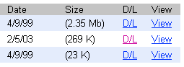  And download 30400f.pdf. Save it with the rest of your documentation.

Wrap Up
Summary | We have now downloaded and installed the MPLAB Integrated Development Environment. We have also downloaded 2 important documents; the 16F84A datasheet and the MPASM quick reference card. These will become the foundation for the following lessons.
Coming Up | In the next lesson, we will write a small program and assemble it in order to test our MPLAB installation and make sure everything is working properly.

